PROJECT REPORT ON

**EBOOK LIBRARY: QUOTE**

In fulfillment of the requirement for

the 5th Semester of

**BACHELORS OF COMPUTER APPLICATION**

Name and Address of the Accredited Institute

Rangia College, Rangia-781354



PROFORMA FOR SUBMISSION OF

STUDENT

PROJECT PROPOSAL/SYNOPSIS

(PROJECT TITLE AND GUIDE DETAILS)

Ebook Library: Quote

Naba Prasad Baro

Balika Baro

Bareigaon krishnanagar

Tamulpur

Tamulpur

781367

Mrs Minakshi Bhuyan

Computer science Department

Rangia College

Rangia- 781354

Name and Address of the student

Name:

S/O:

Village:

Post Office:

District:

Pin:

Title of the Project

Name and Address of the Guide

Signature of the Student Signature of the Guide

(Naba prasad Baro) (Minakshi Bhuyan)

Date: Date:

DECLARATION

I hereby declare that the work done the dissertation entitled “Ebook Library: Quote” carried out by me at Rangia College and submitted in fulfilment of the requirement for 5thSemester BCA program of the same institute under Rangia College.

I also declare that the various contents incorporated in the dissertation have not been submitted in any from the award of any other degree of other institute or university.

Naba Prasad Baro

BCA 5th Semester

Registration no- 22070527

Rangia college, Dist.- Kamrup

CERTIFICATE FROM GUIDE

This is to certify that the project/dissertation report entitled ‘Ebook Library: Quote’ is a bonafide work done by Naba prasad Baro

(GU Registration no- 22070527, 5th semester student of 3RD year BCA course at RANGIA COLLEGE under my personal supervision and guidance. The report is found worthy acceptance for the fulltime fulfillment of the requirements of BCA 5th semester course work for the degree of Bachelors in Computer.

All helps received have been daily acknowledged and no part of these reports has been reproduced for any other degree of diploma.

Signature of Guide/Supervisor Name:

Mrs Minakshi Bhuyan, MCA

Computer Science Department

Rangia College

Rangia-781354

ACKNOWLEDGEMENT

While completing the project, several individuals extended their kind co-operation and help with due encouragement. And I owed a lot of allegiance to all of them for enabling me to complete my project work.

Firstly, I would like to thank the Head of Computer Science Department of Rangia college for his kind permission to carry out a project work.

Secondly, I would like to express my deep sense of gratitude to Mrs Minakshi Bhuyan, my internal guide. They have advisor all thought out my work.

Thirdly to Kriti Deepa Kalita my partner in this Project. She completed this project with me.

To those mention above and to those who inspire and encouraged me, I am expressing gratitude once again.

With due regards

Your sincerely

Naba Prasad Baro

CHAPTER 1: INTRODUCTION

1.1 Project Introduction

1.2 Project Objective

1.3 Tools and Technology

CHAPTER 2: INITIAL SYSTEM STUDY

2.1 Drawback of existing system

2.2 Benefit of proposed system

CHAPTER 3: FEASIBILITY STUDY

3.1 Introduction to SDLC

3.2 Feasibility study

3.2.1 Technical Feasibility

3.2.2 Economical Feasibility

3.2.3 Operational Feasibility

CHAPTER 4: REQUIREMENT ANALYSIS &

SPECIFICATION

4.1 Requirement Analysis

4.2 Requirement Gathering And

Analysis

4.2.1 Requirements Gathering

4.2.2 Analysis of Gathered

Requirements 4.3 Software Requirement

specification

**CONTENT**

CHAPTER 5: SYSTEM ANALYSIS

5.1 Introduction

5.2 Entity Relationship Diagram

5.3 Data flow-diagram

5.4 Data Dictionary

CHAPTER 2: INITIAL SYSTEM STUDY

2.1 Drawback of existing system

2.2 Benefit of proposed system

CHAPTER 3: FEASIBILITY STUDY

3.1 Introduction to SDLC

3.2 Feasibility study

3.2.1 Technical Feasibility

3.2.2 Economical Feasibility

3.2.3 Operational Feasibility

CHAPTER 4: REQUIREMENT ANALYSIS &

SPECIFICATION

4.1 Requirement Analysis

4.2 Requirement Gathering And

Analysis

4.2.1 Requirements Gathering

4.2.2 Analysis of Gathered

Requirements 4.3 Software Requirement

specification

1

**INTRODUCTION**

Project Introduction

Project Objective

Tools and Technology

Chapter 1

INTRODUCTION

1.1 Project Introduction:

QUOTE is a vibrant and inclusive online platform designed to bridge the gap between creators and consumers of literature. It provides a comprehensive space for publishers and individual writers to publish a variety of creative works such as books, poems, short stories, one-shots, fanfiction, and more. By offering powerful tools for showcasing content, it empowers writers to share their works with a diverse global audience.

For readers, the platform is more than just a place to read content. It allows them to deeply engage with the works, following their favourite authors and publishers, providing feedback through likes and detailed reviews, and interacting with the creative community. Readers can also collaborate with each other to build shared libraries, creating spaces to exchange views on literature, share personal collections, and discuss authors' works.

The platform aims to foster an environment where creativity and community engagement thrive. It’s not only about discovering new content but also about building meaningful connections between authors and readers and enabling a dialogue that enhances both the writing and reading experiences.

1.2 Project Objective

The objective of this platform is to redefine how literature is shared and consumed by offering a seamless experience for both writers and readers.

For writers and publishers, the goal is to provide a user-friendly platform where they can publish their works with ease and reach a wide, engaged audience. The platform supports a variety of creative expressions, from long-form novels to short fanfiction, ensuring a place for every literary genre and style.

For readers, the platform seeks to create a collaborative, interactive experience that goes beyond passive reading. Readers are encouraged to explore new works, follow their favourite authors, and provide meaningful critiques through reviews and likes.

In summary, the platform’s objectives are to:

1. Empower authors and publishers with the tools to publish and promote their works effectively.

2. Enable readers to interact with the literary world through likes, reviews, and personalized libraries.

3. Foster a collaborative environment where readers can share their literary tastes and insights with others.

1.3 Tools and Technology

The following tools and technology are used to develop the system.

Hardware:

* Intel core i5/7th gen processor
* Integrated graphics card
* 8gb DDR4 ram
* 1tb HHDS

Frontend Development

* HTML5: For structuring web pages and ensuring semantic content organization.
* CSS3: For styling and creating visually appealing, responsive designs.
* JavaScript: To add interactivity and dynamic content (e.g., likes, reviews, and collaborative libraries).
* Bootstrap: To simplify responsive design with prebuilt components and grid systems.

Backend Development

* Python Flask: A lightweight framework for server-side logic, managing APIs, and user authentication.

Database

* MySQL: For storing and managing structured data, such as user profiles, creative works, reviews, likes, and collaborative libraries.

2

**INITIAL SYSTEM STUDY**

Drawback of existing system

Benefits of Proposed System

Chapter 2

INITIAL SYSTEM STUDY

2.1 Drawback of Existing system:

1. Amazon Kindle

Description: Amazon Kindle is primarily focused on professional authors and publishers. It provides a platform for eBooks and paid content distribution.

Drawbacks:

* High Entry Barrier for New Writers: Requires extensive formatting and often monetary investment to publish.
* Limited Community Engagement: No direct platform for reader-writer interaction, such as collaborative libraries or community discussions.
* Monetization Focus: Geared toward professional monetization rather than creative exploration or community building.
* Complex User Experience: Overwhelming interface for casual or hobbyist writers.

2. FanFiction.net

Description: FanFiction.net specializes in fan-created works based on existing franchises.

Drawbacks:

* Outdated User Interface: The interface is old-fashioned and not mobile-friendly.
* Limited Genres: Primarily focused on fanfiction, restricting original content creators.
* Poor Community Features: Limited interactivity, with no options for collaborative libraries or personalized content sharing.
* Search and Discovery Challenges: Lacks advanced filtering and recommendation systems.

3. Wattpad

Description: Wattpad is a popular platform for writers to share original stories and fanfiction.

Drawbacks:

* Content Oversaturation: Difficult for new authors to gain visibility due to the sheer volume of content.
* Inconsistent Quality: Lack of moderation leads to a mix of high-quality and poorly written content.
* Monetization Bias: Recent updates focus heavily on paid stories, making it less accessible to free content consumers.
* Weak Collaboration Features: Limited tools for shared content creation or community libraries.

2.2 Benefits of Proposed System:

1. Content Publishing: The platform supports the publication of a wide range of creative content, from books and poems to one-shots and fanfiction, allowing writers to reach a global audience.

2. Reader Engagement: Readers are not passive consumers but active participants who can follow their favourite authors or publishers, provide reviews and likes, and contribute to discussions about the content they love.

3. Collaborative Libraries: Readers have the unique ability to create collaborative libraries with other readers. These libraries allow users to share their interests, insights, and favourite works with friends, making the reading experience a shared journey.

4. Author & Publisher Interaction: Writers and publishers have dedicated profiles where they can interact with their readers. They can update followers on new releases, respond to feedback, and build a loyal readership.

5. Community Features: The platform fosters a sense of community through features that allow readers and writers to join discussions, participate in book clubs, and share recommendations.

3

**FEASIBILITY STUDY**

Introduction to SDLC

Feasibility study

Chapter 3

FEASIBILITY STUDY

3.1 Introduction of SDLC (System Development Life Cycle):

The System Development Life Cycle (SDLC) is a systematic framework used to develop, implement, and maintain information systems. It provides a structured approach for managing complex system development projects by dividing them into distinct, manageable phases. SDLC ensures the system meets organizational requirements while being delivered on time, within budget, and with high quality. Following are the Key Phases of the SDLC:

Planning:

* Define project goals and scope.
* Conduct feasibility studies (technical, operational, financial).
* Develop a project plan outlining resources, timelines, and risks

System Analysis:

* Gather and document user requirements.
* Analyze existing systems for improvement opportunities.
* Create requirement specifications for the new system.

System Design:

* Develop the system architecture and data flow diagrams.
* Define technical specifications, including hardware, software, and interfaces.
* Prepare a blueprint for system construction.

Development (Implementation):

* Write and integrate code based on the design specifications.
* Use programming languages, databases, and tools to build the system.
* Conduct unit testing during coding to ensure functionality.

Testing:

* Test the entire system for bugs, compatibility, and performance issues.
* Perform functional, integration, and user acceptance testing.
* Validate that the system meets the defined requirements.

Deployment:

* Install the system in the production environment.
* Train users and provide necessary documentation.
* Roll out the system, either as a pilot or full-scale implementation.

3.2 FEASIBILITY STUDY

Feasibility is the determination of whether or not a project is worth doing. The process followed in making this determination is called feasibility study. This type of study determines if a project can and should be taken. Once it has been determined that a project is feasible, the analyst can go ahead and prepare the project specification which finalizes project requirement.

Normally feasibility studies culminate in a written or oral feasibility report. The contents and recommendations of such a study will be used as a sound basis for deciding whether to proceed, postponed or cancel the project. Thus, since the feasibility study may lead to the commitment of large resources, it becomes necessary that it should be conducted competently and that no fundamental errors of judgment are made. In the conduct of feasibility study, the analyst will usually consider 3 distinct but interrelated types of feasibility.

3.2.1 Technical Feasibility

In examining technical feasibility, configuration of the system is given more importance than the actual makes of hardware. The configuration should give the complete picture about the systems requirements: This can be used as a basis for the tender document against which dealers and manufacturers can later make their equipment bids. Specific hardware and software products can then be evaluated keeping in view with the logical needs.

The technical issues usually raised during the feasibility stage of the investigation include the following: -

Does the necessary technology exist to do what is suggested?

* Does the proposed equipment’s have the technical capacity to hold the data required to use the new system?
* Will the proposed system provide adequate responses to inquiries, regardless of the number or location of users?
* Can the system be upgraded if developed?
* Are there technical guarantees of accuracy, reliability, ease of access and data security?

3.2.2 Economic Feasibility

Economic analyses are used for evaluating the effectiveness of the proposed system. More commonly known as cost/benefit analyses; the procedure is to determine the benefits and saving that are expected from a proposed system and compare them with costs. If benefits outweigh costs, a decision is taken to design and implement the system. Otherwise, further justification or alternative in the proposed system will have to be made if it is to have a chance of being approved. This is an ongoing effort that improves in accuracy at each phase of system lifecycle. As it is the first phase of the project, the cost is estimated.

3.1.3 Operational Feasibility:

Proposed projects are beneficial only if they can be turned out into information systems. That will meet the organizations operating requirements. An operational feasibility aspect of the project is to be taken as an important part of the project implementation.

Some of the important issues raised to test the operational feasibility of a project include the following: -

* Is there sufficient support for the project for management? From users?
* Will the system be used and work properly if it is being developed and implemented?
* Will there be any resistance from the users that will undermine the possible Application benefits?

4

**REQUIREMENT ANALYSIS AND SPECIFICATION**

Requirement Analysis

Requirement Gathering and Analysis

Chapter 4

REQUIREMENT ANALYSIS AND SPECIFICATION

4.1 REQUIREMENT ANALYSIS:

The requirements analysis and specification phase start once the feasibility study phase is completed and the project is found to be financially sound and technically feasible. The goal of the requirements analysis and specification phase is to clearly understand the customer requirements and to systematically organize these requirements in a specification document called Software Requirement Specification (SRS). This phase consists of the following activities:

* Requirements gathering and analysis
* Requirement specification

4.2 REQUIREMENT GATHERING AND ANALYSIS:

As an analyst on should starts the requirement gathering and analysis activity by collecting all information from the customer/user, which could be used to develop the requirements of the system. The two main activities involved in the requirements gathering and analysis phase:

4.2.1. Requirements gathering:

This activity typically involves interviewing the end-users and customers and studying the existing documents to collect all possible information. There are many tools a system analyst may use; the most frequently used tools are given below: -

* Interviews
* Questionnaires
* Brain Storming
* Group Consensus
* On-site Observation
* Reviewing and deriving data from existing system

4.2.2 Analysis of gathered requirements:

The main purpose of this activity is to clearly understand the exact requirements of the user/customer. The following basis questions pertaining to the project should be clearly understood by the analyst in order to obtain a good grasp of the problem:

1. What is the problem?
2. Why is it important to solve the problem?
3. What are the possible solutions to the problem?
4. What exactly are the data input to the system and exactly are
5. data output required of the system?
6. e. What are likely complexities that might arises while solving the problem?

4.3 Software Requirement Specification (SRS):

After the analyst has collect all the requirement information regarding the software to be developed, and has removed all incompleteness, inconsistence, and anomalies from the specification, the analyst systematically organizes the requirements in the form of an SRS document.

1. Contents of the SRS Document:
2. Functional requirement
3. Non-functional requirement
4. Goals of implementation Format of a good SRS document:
   1. Introduction
      1. Background
      2. Overall Description
      3. Environmental Characteristic
      4. Hardware
      5. Peripherals
      6. People
   2. Goals of Implementation
   3. Functional Requirements
   4. Non-functional Requirements
   5. Behavioural Description

o System states

o Events and Actions

Software Engineering Paradigms Applied:

A system engineer must incorporate a development strategy to solve the actual problem in the organization. The strategy that contains the process, method and tests layers and the generic phase referred to as a software engineering paradigm. The software engineering paradigm is chosen on the basis of the nature of the project and application the method and tools to be used, and the delivers that are required.

In the proposed system, the waterfall model constitutes the output of one process becomes the input to another process and this transformation continues till the results is not achieved.

5

**SYSTEM ANALYSIS**

Introduction

Entity Relationship Diagram

Data Flow Diagram

Data Dictionary

Chapter 5

SYSTEM ANALYSIS

5.1 INTRODUCTION:

System Analysis is a critical phase in the development of any information system, aiming to ensure that the system is designed to meet the specific needs of the organization. It involves studying the existing systems, gathering requirements, identifying issues, and designing solutions. The primary goal is to create an efficient, scalable, and user-friendly system that enhances business operations and meets user expectations. A key part of system analysis is the use of various modelling tools that help break down complex systems and structure them in a way that is easy to understand, design, and implement.

Among the most essential tools in system analysis are Entity-Relationship Diagrams (ER Diagrams), Data Flow Diagrams (DFD), and the Data Dictionary. These tools help in visualizing the relationships, data flows, and definitions of data elements within the system. Together, they form a comprehensive approach to documenting and analysing a system’s structure, data requirements, and processes.

5.2 Entity-Relationship Diagram (ER Diagram):

An Entity-Relationship Diagram (ER Diagram) is a high-level conceptual data model used to represent the structure of a system by showing the system’s entities and the relationships between them. This diagram helps in identifying how data is organized and how different components within the system interact with one another. ER diagrams are a powerful tool in visualizing the relationships between real-world entities and the data stored within the system.

1. Entities: These are the key objects or concepts that are involved in the system, represented by rectangles in the ER diagram. Entities are typically nouning such as "Employee," "Customer," or "Product." Each entity is described by its attributes, which define its characteristics.
2. Attributes: Represented by ovals, attributes are the properties or characteristics that describe an entity. For instance, a "Customer" entity may have attributes such as "Customer ID," "Name," "Email," and "Address."

3. Relationships: These are the associations between entities and are represented by diamonds. A relationship defines how two entities are linked together. For example, an "Order" may be related to both "Customer" and "Product," showing which customer placed which order and which products are included in that order.

4. Cardinality: Cardinality defines the number of instances of one entity that can be associated with the number of instances of another entity. Common types of cardinality include one-to-one, one-to-many, and many-to-many.

ER diagrams provide clarity by modelling both the data elements and their relationships, making it easier for developers and analysts to design databases and systems that handle data effectively.

ER diagrams often use symbols to represent three different types of information. Boxes are commonly used to represent entities. Diamonds are normally used to represent relationships and ovals are used to represent attributes. The symbols used in the E-R diagram have its own meanings. They are given below:

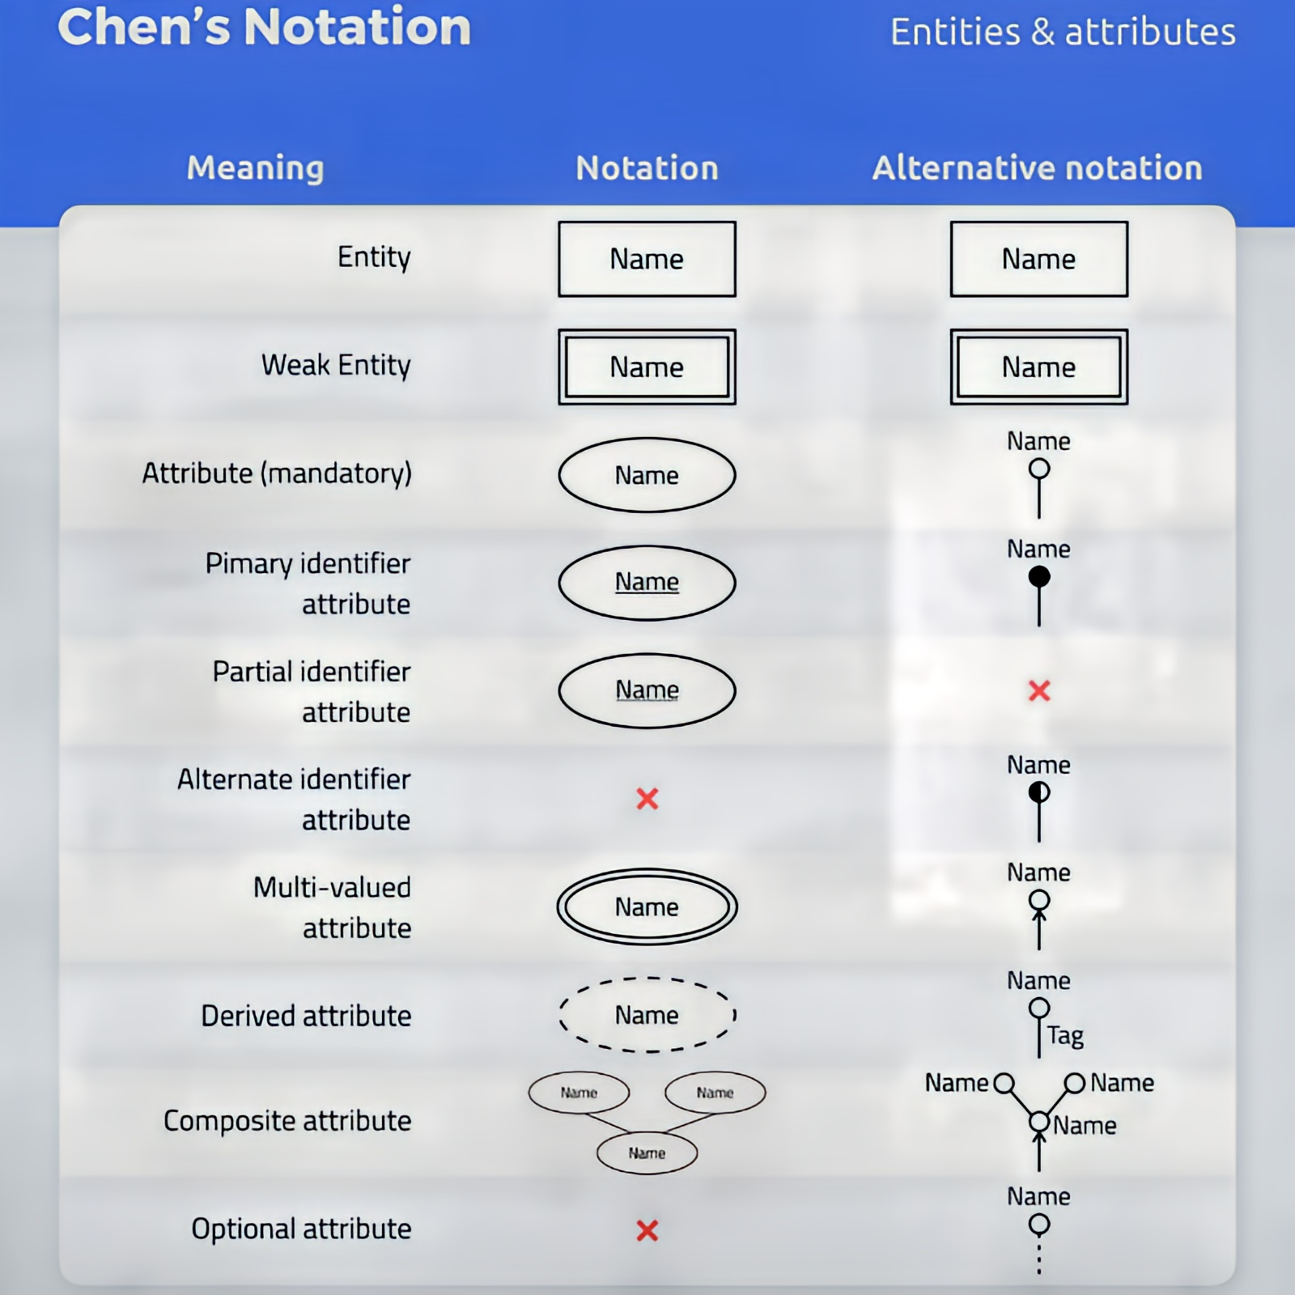

5.3 Data Flow Diagram:

A Data Flow Diagram (DFD) is a graphical representation used to show how data moves through a system. DFDs help illustrate the flow of information between different processes, data stores, and external entities in the system. They provide insight into how data is processed, stored, and used, as well as how it moves through various stages of a system.

1. Processes: Represented by circles or rounded rectangles, processes describe actions that transform input data into output data. For example, a "Process Order" function might take customer order details as input and generate an order receipt as output.
2. Data Flows: Represented by arrows, data flows indicate the movement of data between processes, external entities, and data stores. Each data flow is labelled to show what information is being transferred (e.g., "Order Information" or "Payment Details").
3. Data Stores: Represented by open-ended rectangles, data stores hold data within the system. These can be physical or logical databases, files, or repositories of information that store data temporarily or permanently. For example, an "Inventory Database" could be a data store that holds information about available products.

4. External Entities: Represented by squares or rectangles, external entities are sources or destinations of data that exist outside the system. For instance, "Customer" and "Supplier" are external entities that interact with the system by providing or receiving data.

DFDs are typically represented at multiple levels:

1. Level 0 (Context Diagram): A high-level DFD that shows the system as a whole, illustrating its relationship with external entities and major data flows.
2. Level 1 and beyond: These diagrams break the system into sub-processes, providing a more detailed view of data flow and process interactions.

DFDs are vital for understanding the movement and transformation of data within a system, ensuring that all processes are captured and that the system works efficiently.

5.4 Data Dictionary:

A Data Dictionary is a centralized repository or catalogue that defines all the data elements used in a system. It provides a comprehensive reference for the system’s data components, ensuring consistency, clarity, and proper usage across the development and operational teams. The data dictionary defines the structure, meaning, and rules associated with each data element, offering crucial information for system design, implementation, and maintenance.

1. Data Elements: These are the smallest units of data, such as fields or variables. For example, a "Customer ID" field could be defined as a data element that holds a unique identifier for each customer.
2. Attributes and Properties: The dictionary specifies the attributes and properties of data elements. For example, a "Date of Birth" field might be defined as a date with a specific format (e.g., MM/DD/YYYY).
3. Relationships Between Data Elements: The data dictionary also documents how different data elements relate to one another, including the dependencies and associations that impact data integrity and functionality.
4. Data Types: Each data element's type is defined in the dictionary, such as integer, string, or Boolean, to ensure that data is used correctly in processing.

The data dictionary acts as a reference for all stakeholders involved in the system's development and provides a clear understanding of data usage, consistency, and structure.

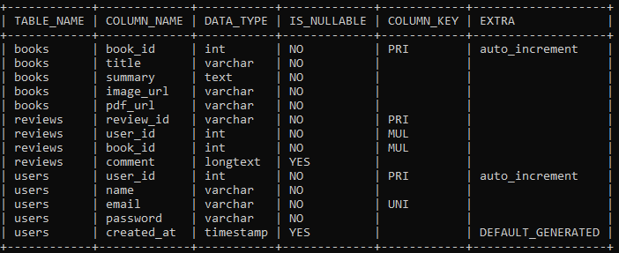

DATA DICTIONARY OF THE PROPOSED SYSTEM

6

**SYSTEM DESIGN**

Introduction

Entity Relationship Diagram

Chapter 6

SYSTEM ANALYSIS

6.1 INTRODUCTION:

The system design for QUOTE provides a robust and scalable foundation to support the platform’s goals of creative publishing and interactive community engagement. It focuses on enabling seamless content management for authors and immersive experiences for readers, leveraging modern technologies for efficiency and growth.

Key objectives include:

* Content Publishing: Enable authors and publishers to easily upload and manage books, poems, stories, and fanfiction.
* Reader Interaction: Support features like likes, reviews, and following to foster connections between readers and authors.
* Collaborative Libraries: Allow readers to create and manage shared libraries for exchanging insights and personal collections.
* Community Building: Include discussion forums, book clubs, and recommendations to create a vibrant literary community.

This design ensures a user-friendly, scalable platform that meets the diverse needs of a global user base while supporting future enhancements.